**EXP26.CREATE A SQL STORAGE SERVICE AND PERFORM A BASIC QUERY USINGANY PUBLIC**

**CLOUD SERVICE PROVIDER (AZURE/GCP/AWS) TO DEMONSTRATE DATABASE AS A SERVICE**

**(DAAS)**

**AIM**: CREATE A SQL STORAGE SERVICE AND PERFORM A BASIC QUERY USINGANY PUBLIC CLOUD

SERVICE PROVIDER (AZURE/GCP/AWS) TO DEMONSTRATE DATABASE AS A SERVICE (DAAS)

**PROCEDURE:**

STEP1: GOTO AZURE AND GOTO SQLDATABASE.

STEP 02: NOW CREATE A SQL DATABSE

STEP3: SELECT THE RESOURCE GROUPAND ENTER THE SERVERNAMETHATAPPLICABLE.

STEP4: IN NETWORKING SELECT ALLOW AZURE SERVICES AND

RESOURCES TO ACCESS THIS SERVER.

STEP5: IN ADDITIONAL SETTINGS SELECT SAMPLE.

STEP6:AND THE SQL DATABASE IS DEPLOYED

TEP7: NOW GOTO QUERY EDITOR.

STEP8: NOW AGAIN LOGIN TO THE SQLDATADATABASE

STEP9: OUR TABLES WILL SHOWN AND TYPE THE QUERY TO EXCUTED.

**IMPLEMENTATION:**

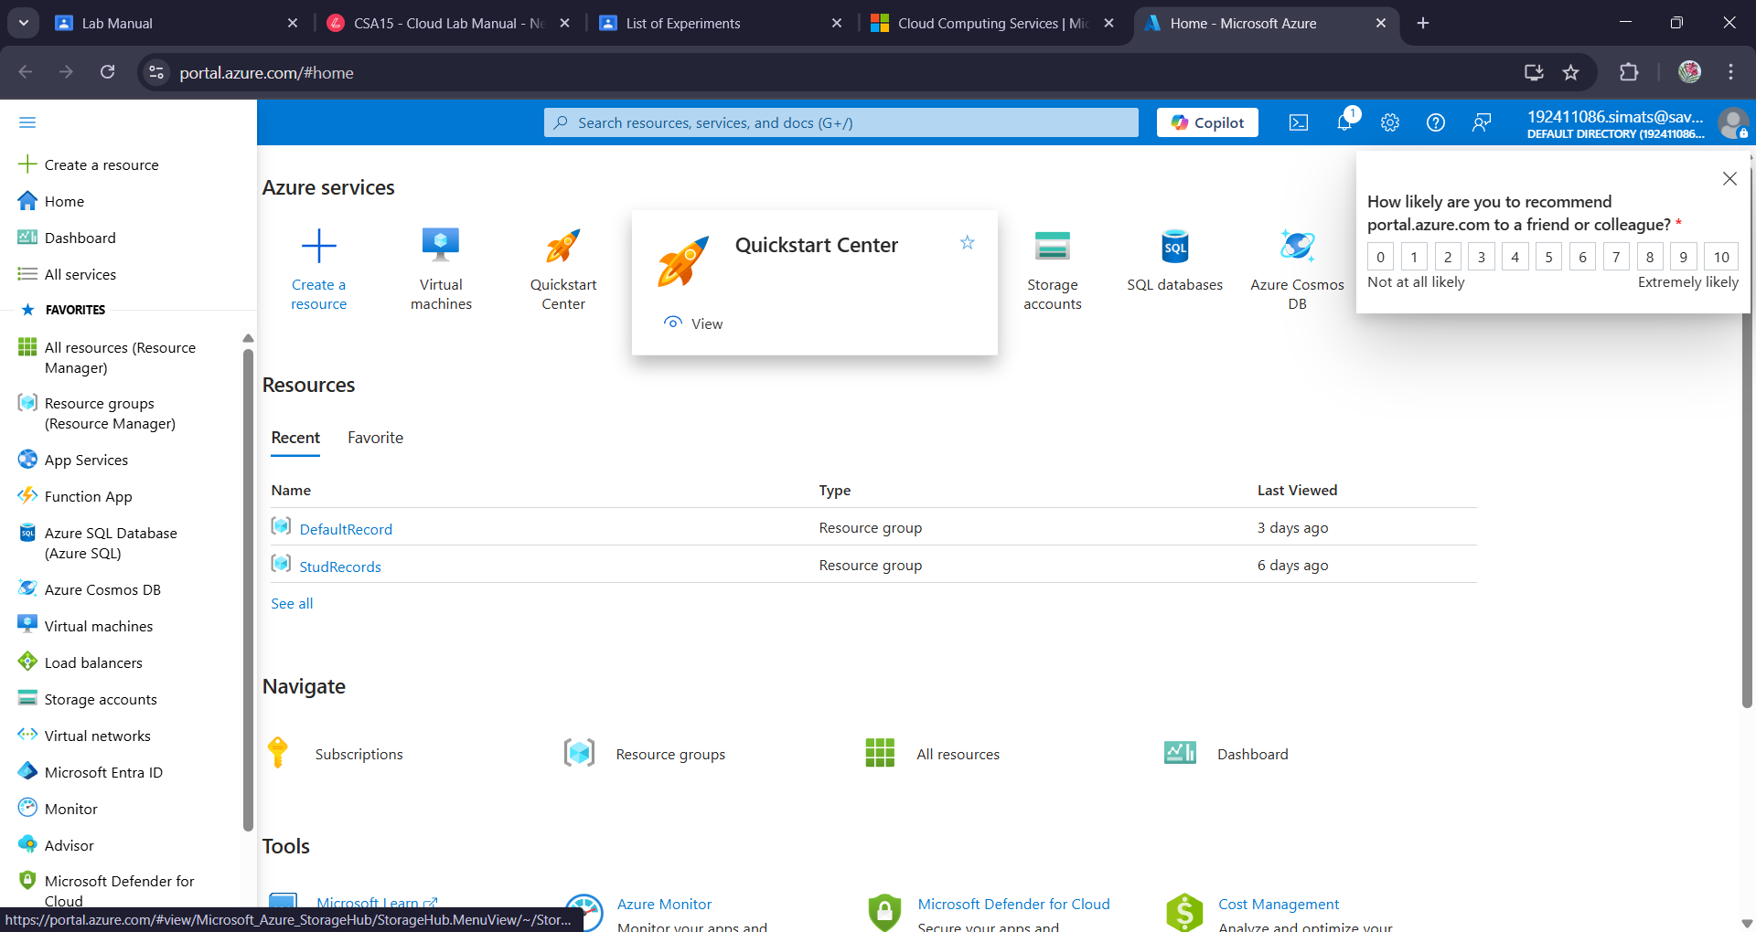

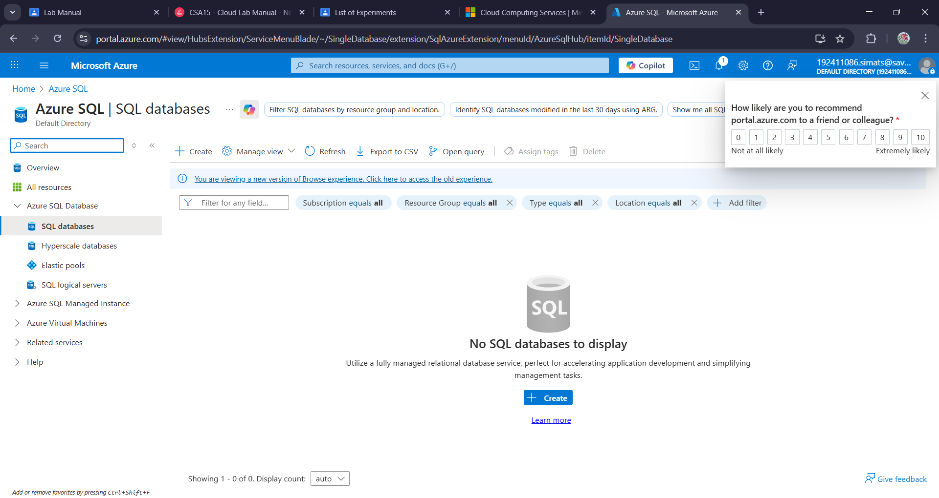

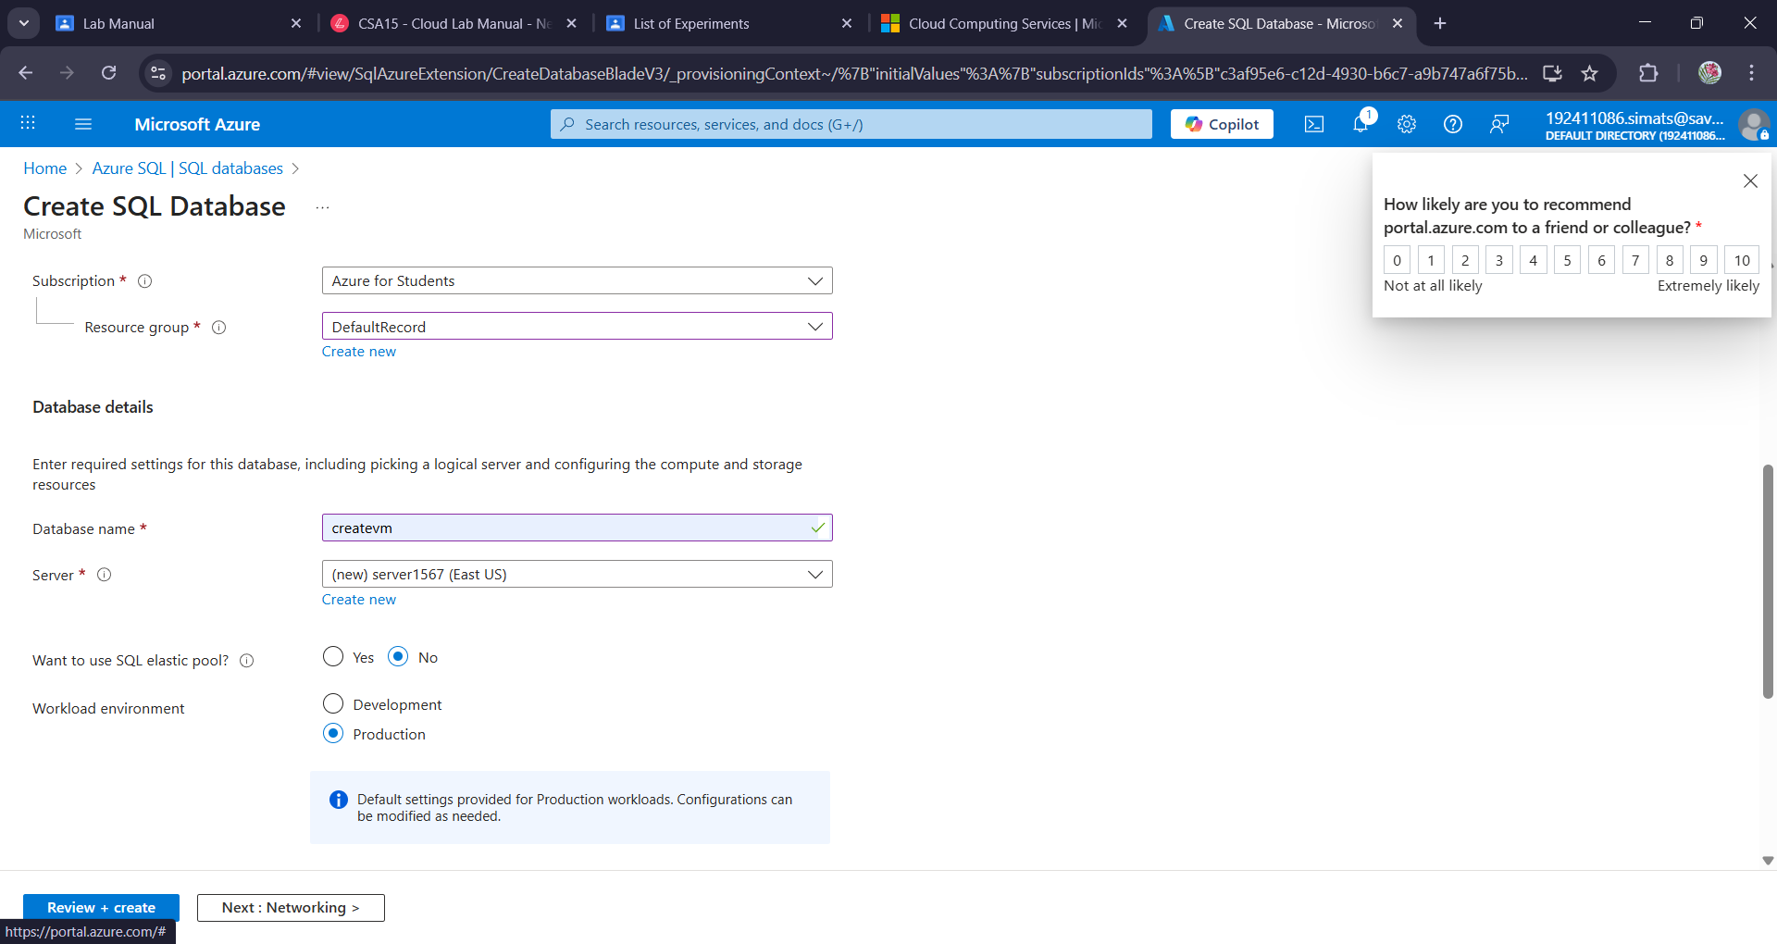

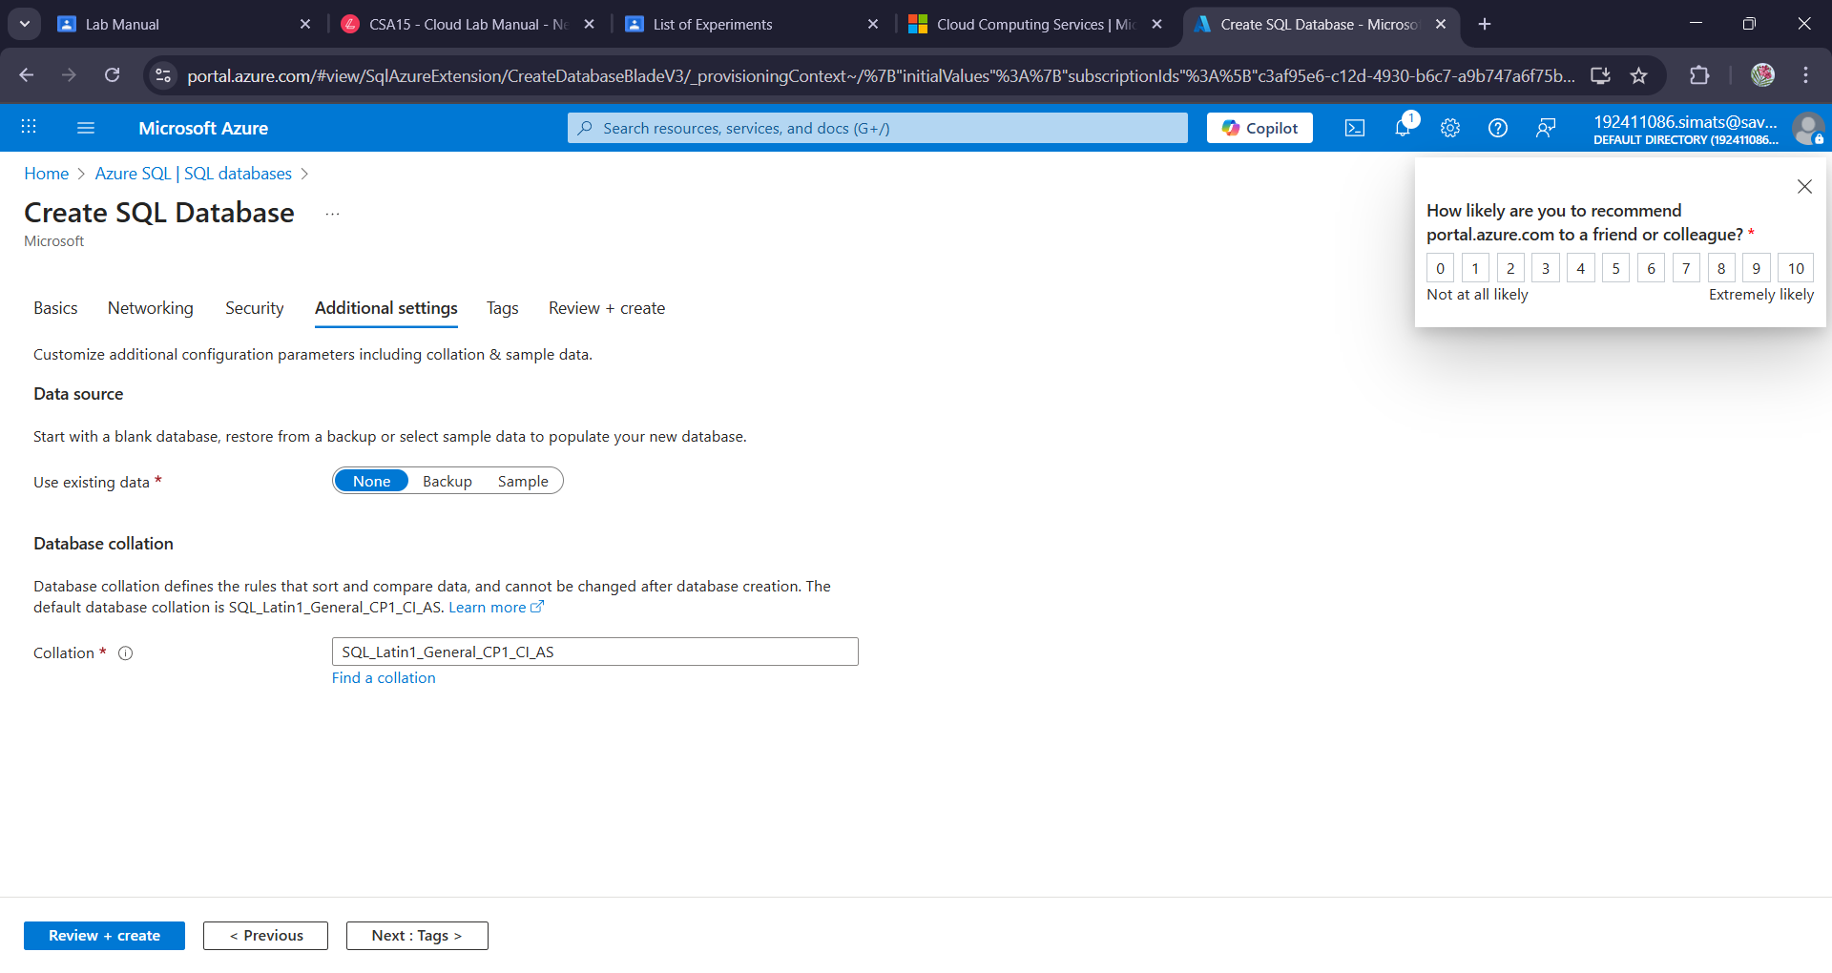

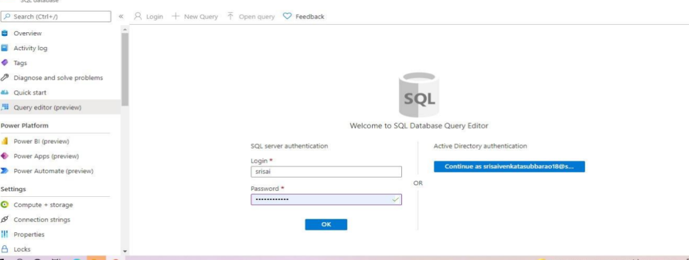

**Result:**

A sql storage service and perform a basic query usingany public cloud service provider (azure/gcp/aws) to demonstrate database as a service (daas) has been created.